STUDENT HANDOUT HTML-CHAPTER2

NAVIGATION AND VISUAL ELEMENTS

**About Workshop:**

In this workshop, you will learn how to incorporate images, lists, links, and frames into your job portal web application. In this chapter, we are divided into five workshops, each of which illustrates how to effectively utilize these elements in your application. You can also make use of the previously learned tags.

The Scrum Master can divide the workshop among team members, and you can proceed to walk through the tasks assigned to you.

**WORKSHOP1:**

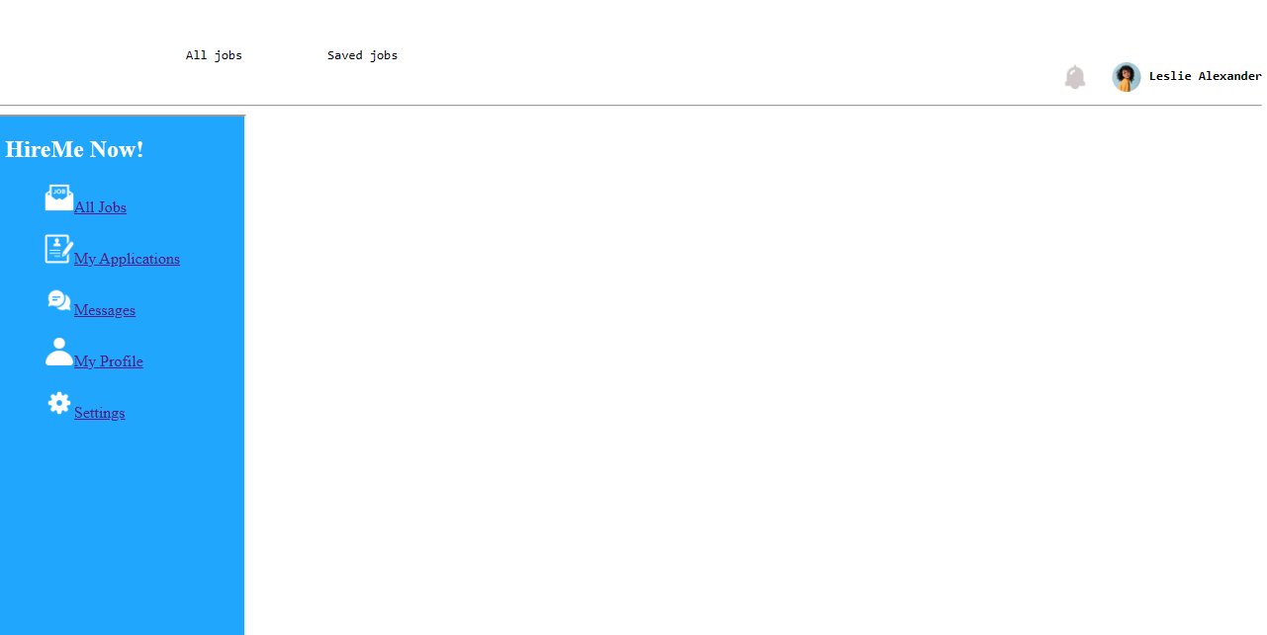

Expected output:-

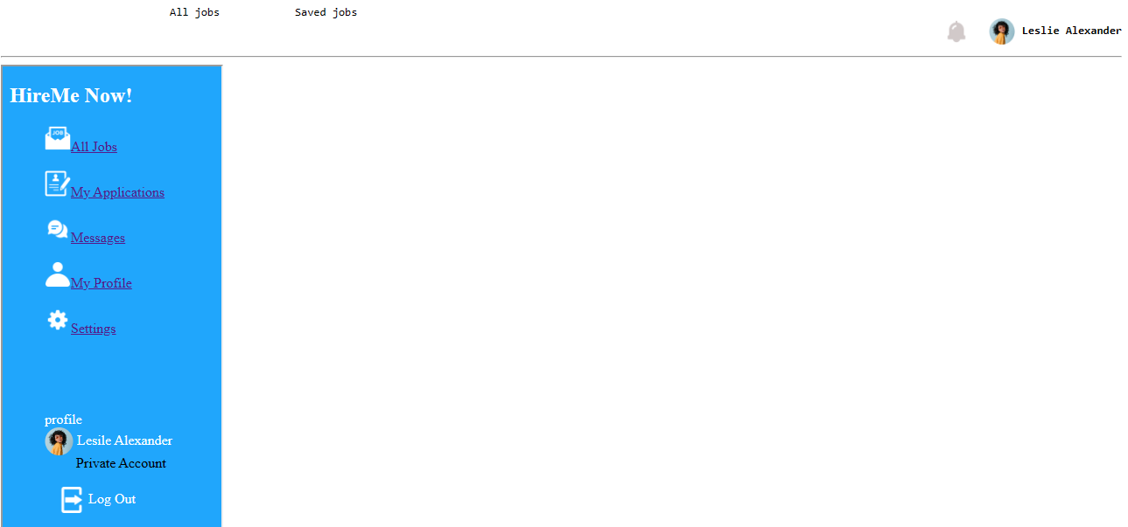

During this workshop, we will be constructing a homepage for job seekers. On this page, you will notice the presence of both a header and a sidebar, both of which are created using frames. Within the sidebar, the navigation links are structured using an unordered list, and the bullet points have been removed using the 'type' attribute with a value of 'none'. Additionally, an image has

been incorporated before each list item.Towards the bottom of the sidebar, a profile picture has been included, and its dimensions have been adjusted

using height and width attribute.The header is positioned using the 'pre' tag, and an image has been inserted.

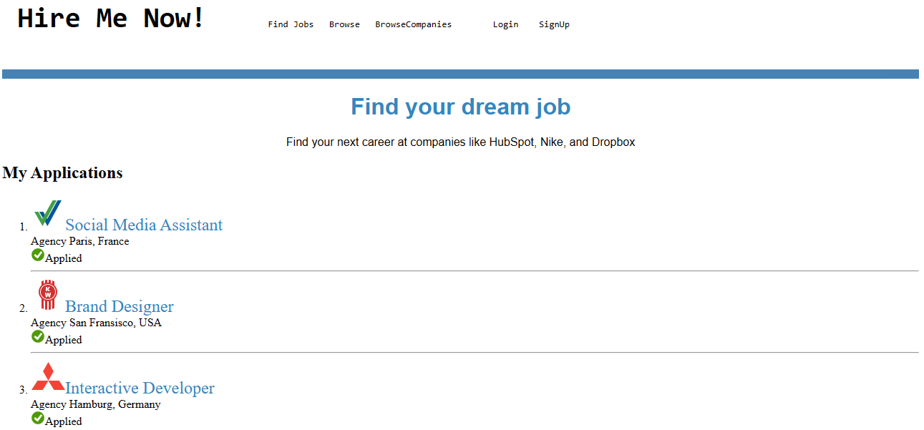

Clicking on a sidebar link will navigate to the corresponding page.

**WORKSHOP2:**

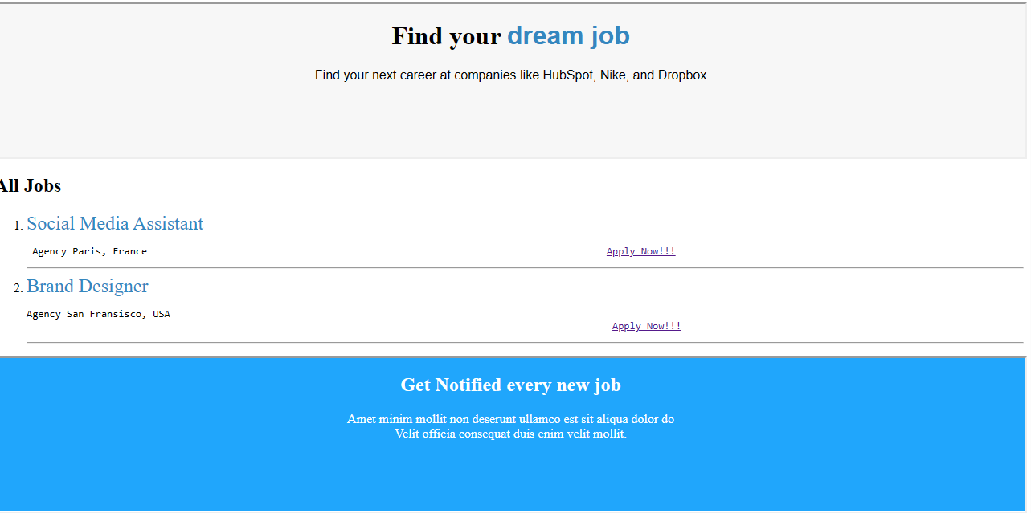

Expected output:-

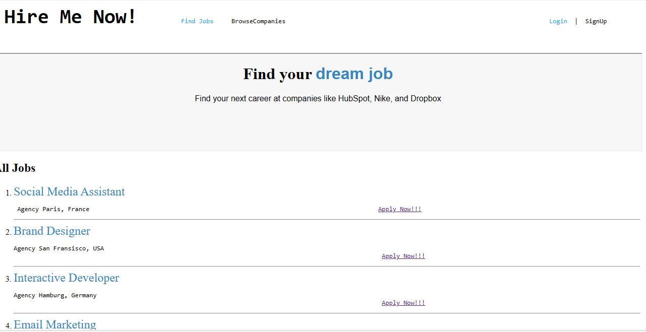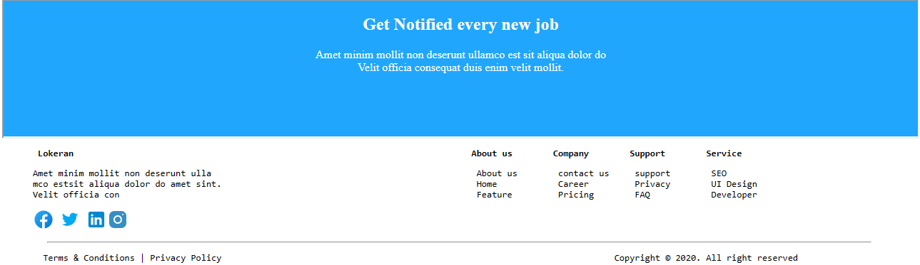

In this workshop, we will design a platform for job seekers to find job opportunities. The page layout comprises different frames, each linked to the main page. Additionally, when users click on the 'Apply Now' link, it will redirect them to the login page. The job listings are structured using ordered lists and incorporate previously learned HTML tags.

WORKSHOP3:-

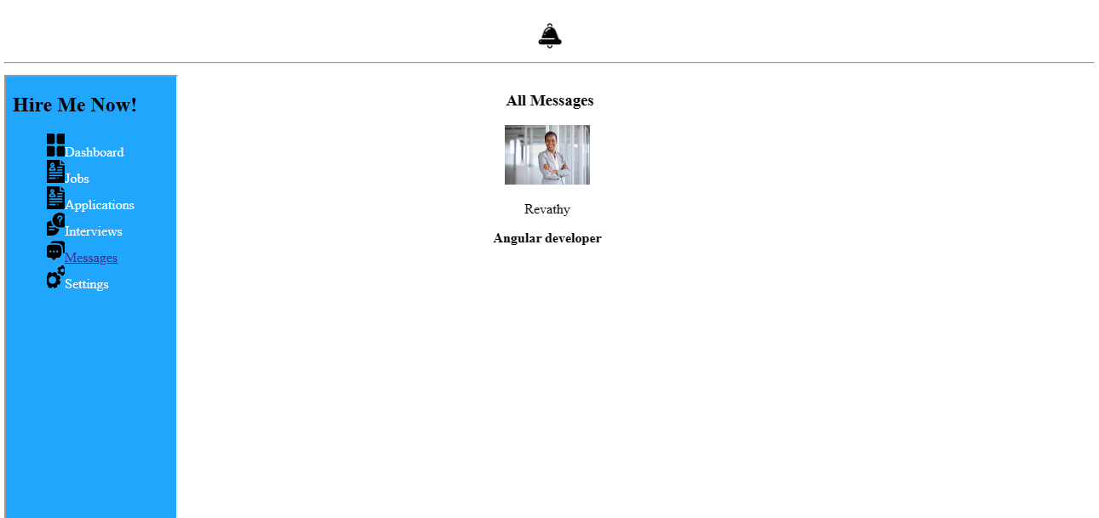

Expected Output:-

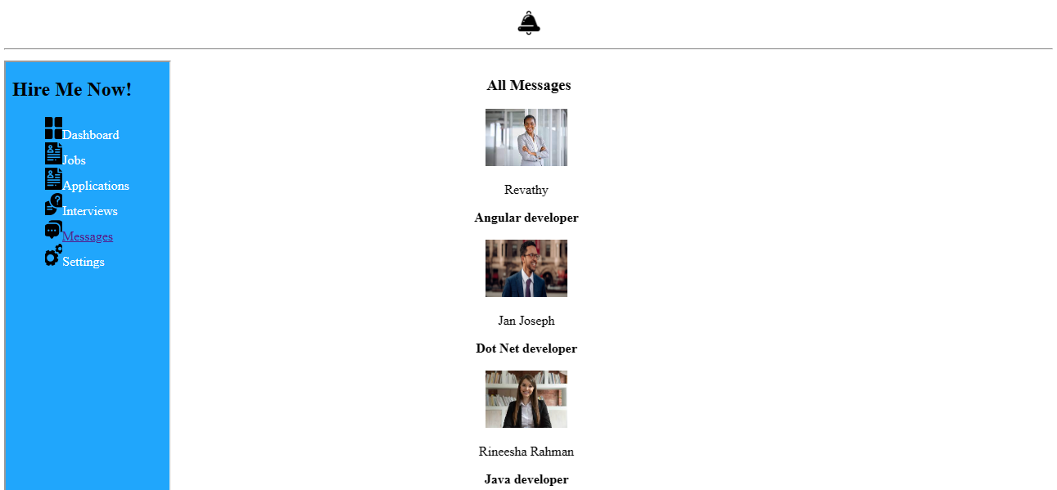

In Workshop 3, the job providers' messaging screen is composed of three

parts: a header, a sidebar, and main content. These parts consist of various frames that are attached to the mainframe and aligned using the **<pre>** tag. In the sidebar, all the links are created using lists. When clicking on the message link, it will redirect to the same page, and the main content will display the message list.

WORKSHOP4:-

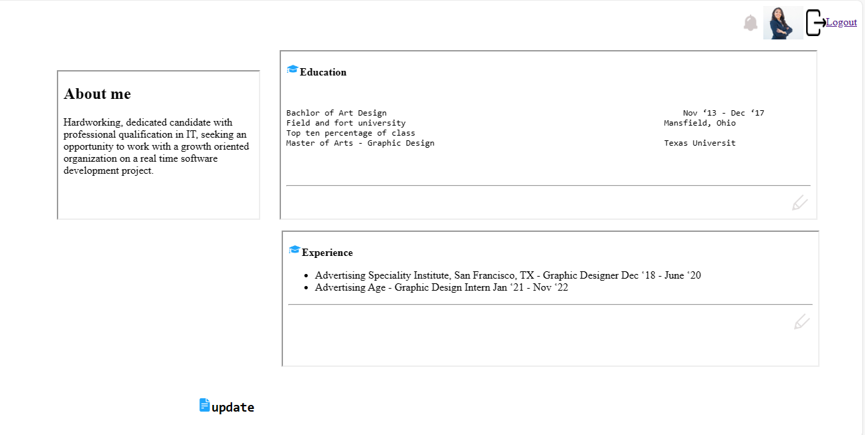

Expected Output:-

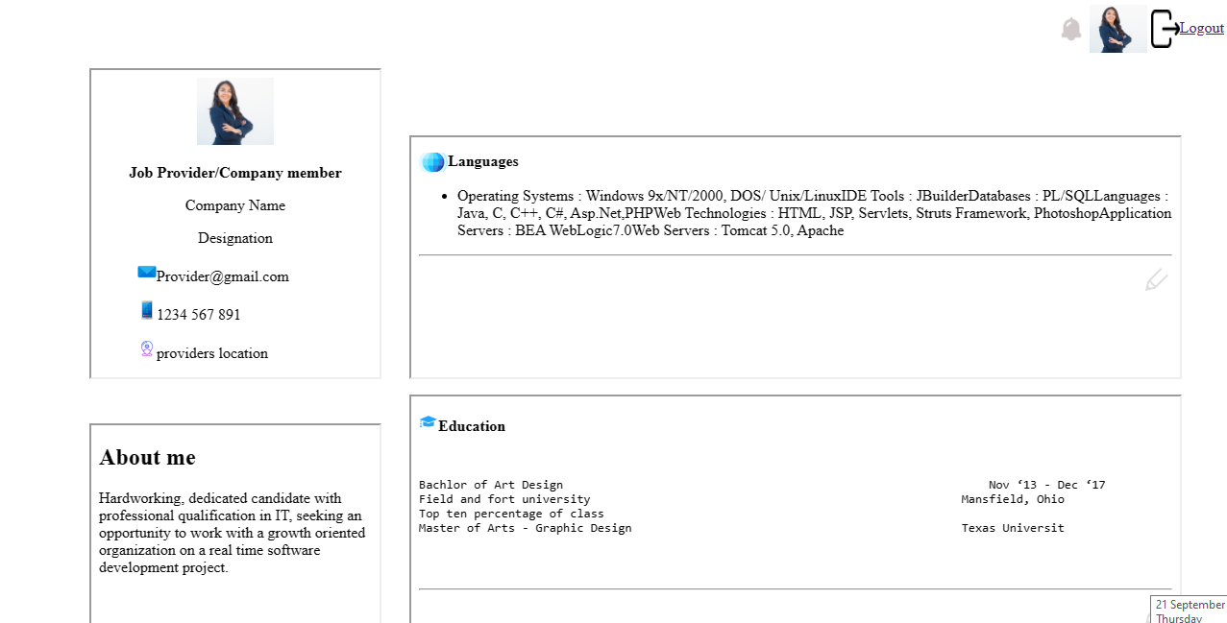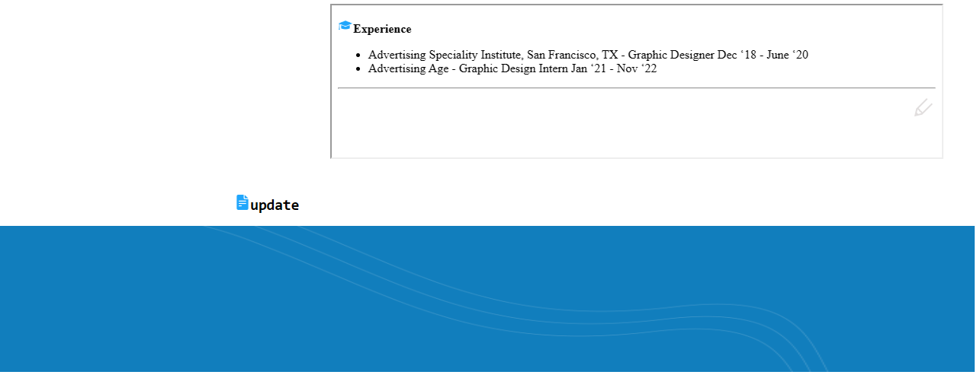

Workshop 4 showcases the job providers' company profile, with all sections composed of frames attached to the main frame. Images and links have also been included. When you click on the logout button, it redirects you to the index page of the workshop.

WORKSHOP5:-

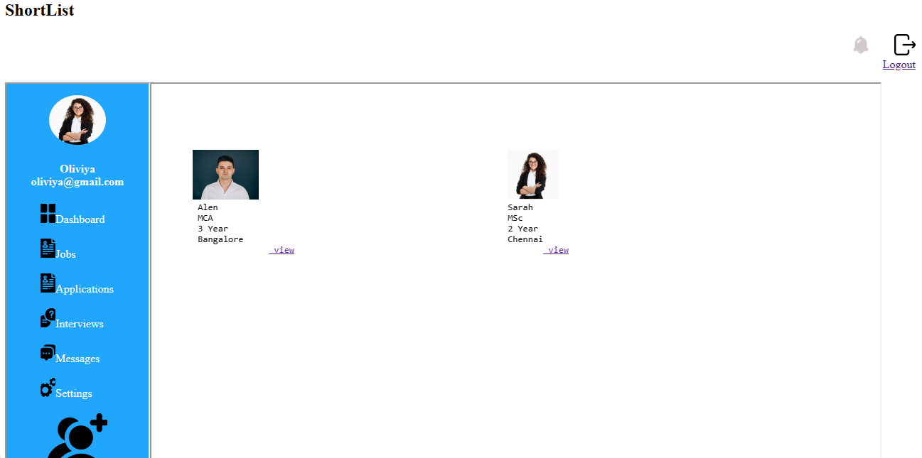

Expected Output:-

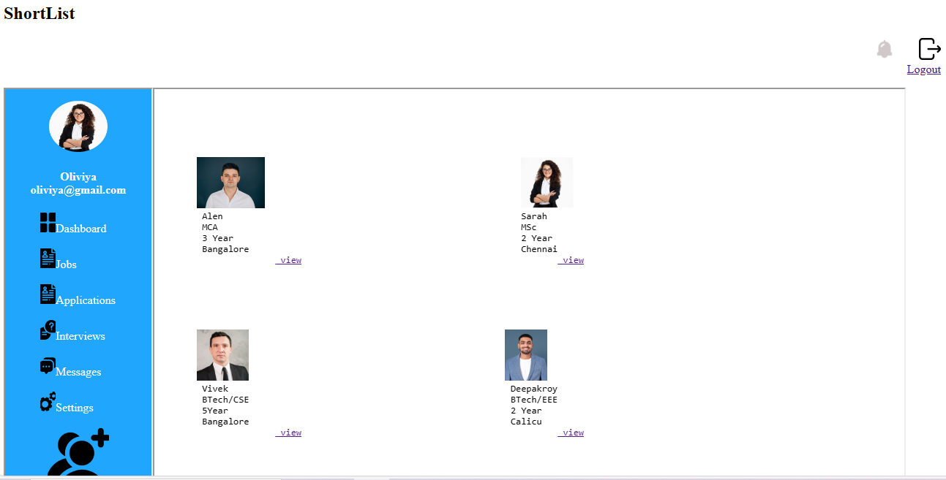

Workshop 5 displays shortlisted candidates. This page is composed of a header, a sidebar, and a content area. The sidebar is constructed using lists and links, while the content area includes images and lists where you can learn about various attributes of links and lists frames. Clicking on the logout button will redirect you to the index page.